7. UV Module – Technical Details
7.1 Wavelength & Power

The ES-AQUA UV module operates at 254 nm UV-C, the globally recognized standard wavelength for water disinfection.

Typical performance parameters:

- UV-C LED or tube: 1–5 W optical output
- Electrical power: 5–12 W (depending on LED type)
- Target UV dose: ≥ 40 mJ/cm²

This dose is sufficient to inactivate:

- bacteria (e.g., E. coli)
- viruses (e.g., Rotavirus)
- protozoa (e.g., Giardia)

7.2 Quartz Glass Window
The UV module uses a high-transmission quartz glass window because:

- standard glass blocks UV-C
- quartz transmits > 90% at 254 nm
- it is heat-resistant
- chemically inert

The window is fully enclosed within a shielded housing.

7.3 UV Dose Calculation
For ES‑AQUA:

• target dose: ≥ 40 mJ/cm²
• minimum exposure time: 40–60 seconds
• dependent on:
• LED power
• distance to water
• flow rate

7.4 Minimum Exposure Time
The UV chamber is designed to ensure:

- slow enough flow
- complete exposure
- no shadow zones

Typical values:

- flow rate: 0.3–0.6 L/min
- contact time: ≥ 40 seconds

8. Theoretical Effectiveness Analysis
8.1 Mechanical Filtration

Removes:

• sand
• silt
• suspended solids
• turbidity

Effectiveness: high, depending on sand quality.

8.2 Activated Carbon Adsorption
Removes:

• chemicals
• pesticides
• odors
• taste compounds
• organic contaminants

Effectiveness: medium to high, depending on carbon quality

8.3 Microfiltration
Removes:

• bacteria (partially)
• microplastics
• fine particles

Effectiveness: medium, with optional membrane very high.

8.4 UV‑C Disinfection
Inactivates:

• bacteria: > 99.99%
• viruses: > 99.9%
• protozoa: > 99%

UV‑C is one of the most reliable water disinfection methods.

9. Graphic Design Guide
(This section describes the graphics so designers can reproduce them accurately.)

9.1 Exterior View
• cylindrical housing
• inlet at top, outlet at bottom
• blue‑white color scheme
• Auron/ES emblem on the front

9.2 Cross-Section View
From top to bottom:

- coarse gravel
- fine gravel
- quartz sand
- activated carbon
- microfiber layer
- optional membrane
- UV chamber
- Outlet

9.3 Functional Diagram

• arrows showing water flow
• UV chamber highlighted
• barrier chain color‑coded

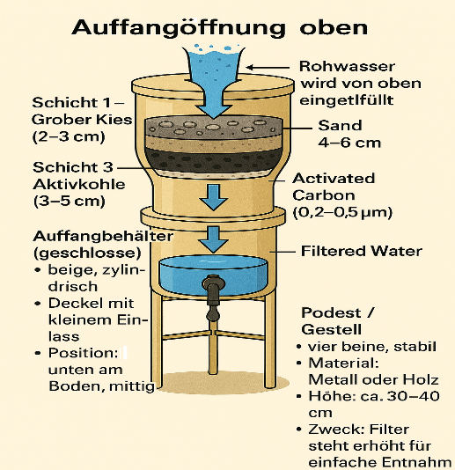

9.4 Detail Graphics
• UV module
• quartz window
• activated carbon layer
• backwash valve

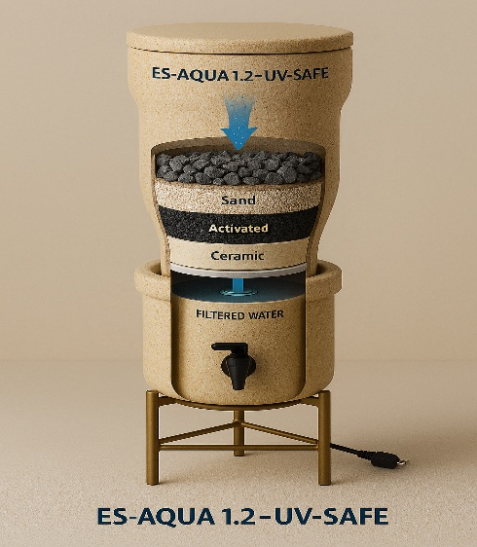

10. Deployment Areas & Humanitarian Impact
10.1 Villages

• household supply
• community wells
• schools

10.2 Camps

• refugee camps
• emergency shelters
• mobile water stations

10.3 Crisis Zones

• natural disasters
• epidemics
• conflict areas

10.4 Off‑Grid

• expeditions
• rural regions
• temporary settlements

11. Safety Sheet
11.1 Material Requirements

• food‑grade plastics only
• no toxic adhesives
• quartz sand instead of construction sand

11.2 UV Safety

- UV light must not escape
- quartz window fully shielded
- no direct line of sight to LED

11.3 Hygiene

• regular cleaning
• avoid touching filter layers with dirty hands
• do not inhale activated carbon dust

12. Status & Validation
12.1 Test-Ready

The system is ready for:

- laboratory testing
- NGO field trials
- governmental validation

12.2 Laboratory Requirements

- microbiological testing
- UV dose measurement
- flow rate measurement
- material analysis

12.3 Further Development

Planned improvements:

• optimized UV chamber
• modular filter cartridges
• solar‑powered option
• quick‑assembly system

